**体育课 13：20**

**所有换表情在我们的男主基础上换个表情就行**

**（背景1）**

[**http://m.qpic.cn/psc?/V54DWESa0sRAoU0aTodf0ZH2Ht0OfYHO/45NBuzDIW489QBoVep5mcT1O4m0dyHutdziMDLHQEMunsedg6HSqHOrp12JjF*bifrBJzn6WdBiQGjVj45LQJmQMQzJ70uARuwTlBqANb44!/b&bo=OASgBQAAAAABJ5k!&rf=viewer_4**](http://m.qpic.cn/psc?/V54DWESa0sRAoU0aTodf0ZH2Ht0OfYHO/45NBuzDIW489QBoVep5mcT1O4m0dyHutdziMDLHQEMunsedg6HSqHOrp12JjF*bifrBJzn6WdBiQGjVj45LQJmQMQzJ70uARuwTlBqANb44!/b&bo=OASgBQAAAAABJ5k!&rf=viewer_4)

**我：终于到了体育课了**

**（背景2）**

**http://m.qpic.cn/psc?/V54DWESa0sRAoU0aTodf0ZH2Ht0OfYHO/45NBuzDIW489QBoVep5mcU6cieagA3q8PHRZv0omgYkHgrVehAVAwYSAA5eeeIyVP4Sp9DyUPwGKQQXubJEIt*ZGO2S2qcZOafIJbKJYd2Y!/b&bo=OARABgAAAAABJ3o!&rf=viewer_4**

**老师：大家好，欢迎来到篮球的世界。**

**老师：我们的期末考试会考察大家的三步上篮，我相信大家都是会的，不会也没有关系，很容易学会的，大家放松些**

**（背景3）**

**http://m.qpic.cn/psc?/V54DWESa0sRAoU0aTodf0ZH2Ht0OfYHO/45NBuzDIW489QBoVep5mcT1O4m0dyHutdziMDLHQEMs65D1uVcJQhkJCFh*5b6JugEb76tZVWVG*qw9EYIy0q60F1iovKKqE4uuhiURQ0cY!/b&bo=OATABgAAAAABF8o!&rf=viewer_4**

**我：这是天堂吗，高中体育课我主要学的是化学、物理和数学，现在终于能整节课打篮球了**

**（背景2）如上上个场景**

**http://m.qpic.cn/psc?/V54DWESa0sRAoU0aTodf0ZH2Ht0OfYHO/45NBuzDIW489QBoVep5mcU6cieagA3q8PHRZv0omgYkHgrVehAVAwYSAA5eeeIyVP4Sp9DyUPwGKQQXubJEIt*ZGO2S2qcZOafIJbKJYd2Y!/b&bo=OARABgAAAAABJ3o!&rf=viewer_4**

**老师：首先，我们来热身吧**

**加入投篮小游戏**

**（背景4）**

**http://m.qpic.cn/psc?/V54DWESa0sRAoU0aTodf0ZH2Ht0OfYHO/45NBuzDIW489QBoVep5mcSX7MClA.K.RCnAnLXBti8I9yWPCXoHV2tmX4OT7oKVcbFCnON6qrQ0ozpUPV7.*5Gc4*tYjUliMxabJt*OMYF8!/b&bo=OARABgAAAAABF0o!&rf=viewer_4**

**老师：这节课我给大家讲一讲三步上篮的动作要领**

**（背景5）男主表情如下 ，主人公：男主**

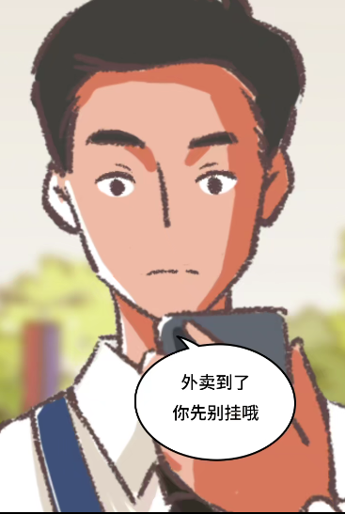

**我：我想打球，我想打球，我想打球……**

**（背景6）**

**http://m.qpic.cn/psc?/V54DWESa0sRAoU0aTodf0ZH2Ht0OfYHO/45NBuzDIW489QBoVep5mcSX7MClA.K.RCnAnLXBti8KmQ8fAfA.ooIZ0FWw30j3RMvvM4dNx2uMU5wFDXveLVD3OwlKoNymXtF6akf4v5HI!/b&bo=OARABgAAAAABF0o!&rf=viewer_4**

**加入转场，表示动作讲解完成**

**可以放一张体育场的图，在上面加上文字“老师讲解后”**

**（背景2）**

**老师：现在大家练习三步上篮吧**

**（背景7）表情如下主人公：男主**

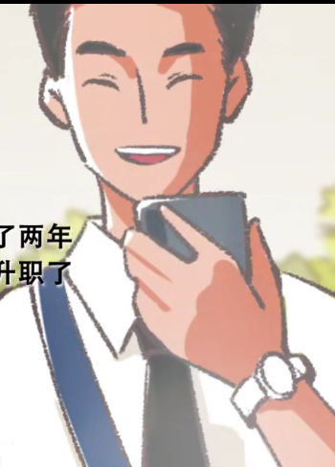

**我：耶！！！终于讲完了。**

**（背景8）拍一张手捡篮球的图片（仅图片）**

http://m.qpic.cn/psc?/V54DWESa0sRAoU0aTodf0ZH2Ht0OfYHO/45NBuzDIW489QBoVep5mcSX7MClA.K.RCnAnLXBti8LTtKRd4oyqw54fGSm57M.kAdzO1YAy2HcjdlZB87LKGp9W.xwqCkVV3Oy3Ph9s.w4!/b&bo=OARABgAAAAABF0o!&rf=viewer_4

**（背景9）**

**http://m.qpic.cn/psc?/V54DWESa0sRAoU0aTodf0ZH2Ht0OfYHO/45NBuzDIW489QBoVep5mccYeZQf6Jhd6Ga41ebdMegRPaA8Ajs2mRgtCVcT1zfqNTRYEzrl5AEBhnF1QsDXFVeEhnxgGTmENvrKNnXMUUko!/b&bo=OATABgAAAAABF8o!&rf=viewer_4**

**（背景10）**

**http://m.qpic.cn/psc?/V54DWESa0sRAoU0aTodf0ZH2Ht0OfYHO/45NBuzDIW489QBoVep5mccYeZQf6Jhd6Ga41ebdMegR9lYtFfCvs25pWcJsqD53ff08WGwlcT2dB3K6i9q4J00Nn4HH6lvXwBzR6KBEPD5o!/b&bo=OATABgAAAAABF8o!&rf=viewer_4**

**（背景11）**

**http://m.qpic.cn/psc?/V54DWESa0sRAoU0aTodf0ZH2Ht0OfYHO/45NBuzDIW489QBoVep5mccYeZQf6Jhd6Ga41ebdMegSuuKF4ups9PFOKfTF2ZCQQ5wx6cHnMBjjdVXIuXIcpR*kqfYmDuFr0oZOY3nYXsu8!/b&bo=OATABgAAAAABF8o!&rf=viewer_4**

**（背景12）在篮筐旁加一个“哐！！！”，男主摔倒（仅图片）**

**http://m.qpic.cn/psc?/V54DWESa0sRAoU0aTodf0ZH2Ht0OfYHO/45NBuzDIW489QBoVep5mcWHg7QSRLPfS7QZc4hBZwZffSSrBbSTcstgbvEpRMierp3Z6wKZBCtywG5kQmr3toSxz7jbF3tz3lI0BVftNLMU!/b&bo=OATABgAAAAABF8o!&rf=viewer_4**

**我：没投中，糟糕**

**（背景13）老师严肃图**

**老师：蒋肃京，你过来一下**

**老师：你是魔鬼吧！**

**（背景14）男主发朋友圈**

**http://m.qpic.cn/psc?/V54DWESa0sRAoU0aTodf0ZH2Ht0OfYHO/45NBuzDIW489QBoVep5mcUDqXUbb7ATY9X7D8.yDHr*jNIU.8Xc9Bi2INm59YqqoTKpBqYFnf4oFome6rioG4jXSgpp8AlBRzNnNgguyNmo!/b&bo=OASgBQAAAAABF6k!&rf=viewer_4**

**（背景15）**

**http://m.qpic.cn/psc?/V54DWESa0sRAoU0aTodf0ZH2Ht0OfYHO/45NBuzDIW489QBoVep5mcT1O4m0dyHutdziMDLHQEMunsedg6HSqHOrp12JjF*bifrBJzn6WdBiQGjVj45LQJmQMQzJ70uARuwTlBqANb44!/b&bo=OASgBQAAAAABJ5k!&rf=viewer_4**

**我：终于下课了，我要再练练篮球**

**（背景16）**

[**http://m.qpic.cn/psc?/V54DWESa0sRAoU0aTodf0ZH2Ht0OfYHO/45NBuzDIW489QBoVep5mccYeZQf6Jhd6Ga41ebdMegSuuKF4ups9PFOKfTF2ZCQQ5wx6cHnMBjjdVXIuXIcpR7trlLRJqaD3yFrd1MFhDDU!/b&bo=OATABgAAAAABF8o!&rf=viewer_4**](http://m.qpic.cn/psc?/V54DWESa0sRAoU0aTodf0ZH2Ht0OfYHO/45NBuzDIW489QBoVep5mccYeZQf6Jhd6Ga41ebdMegSuuKF4ups9PFOKfTF2ZCQQ5wx6cHnMBjjdVXIuXIcpR7trlLRJqaD3yFrd1MFhDDU!/b&bo=OATABgAAAAABF8o!&rf=viewer_4)

**（背景17）**

[**http://m.qpic.cn/psc?/V54DWESa0sRAoU0aTodf0ZH2Ht0OfYHO/45NBuzDIW489QBoVep5mcRGBTSxTXHgGERyCTKc7ly2NSJh6MXcfTPTFW*scLAp5aPel5RqapGsmXpUbFCKPBq3915mI9Bqy6KcOpD68CBU!/b&bo=OARABgAAAAABF0o!&rf=viewer_4**](http://m.qpic.cn/psc?/V54DWESa0sRAoU0aTodf0ZH2Ht0OfYHO/45NBuzDIW489QBoVep5mcRGBTSxTXHgGERyCTKc7ly2NSJh6MXcfTPTFW*scLAp5aPel5RqapGsmXpUbFCKPBq3915mI9Bqy6KcOpD68CBU!/b&bo=OARABgAAAAABF0o!&rf=viewer_4)

**我：糟糕！球飞了……**

**（背景18）**

**http://m.qpic.cn/psc?/V54DWESa0sRAoU0aTodf0ZH2Ht0OfYHO/45NBuzDIW489QBoVep5mcT1O4m0dyHutdziMDLHQEMvSgCONzv5WIHDrDvNuC1.*4Iz*RC1pGwtUz15bkua379aXimBovVQZ4FHWLq16iJA!/b&bo=OARABgAAAAABJ3o!&rf=viewer_4**

**我：哎哎哎！那个同学，小心球。**

**（背景19）**

[**http://m.qpic.cn/psc?/V54DWESa0sRAoU0aTodf0ZH2Ht0OfYHO/45NBuzDIW489QBoVep5mcRqGvafBxgytM2AKTxVlaGDcplU1YRGF2QoP0iWJig*vUH2l5tgVVoCnyrmBTERgYmWYQgW8ACF2z6LB1smXipc!/b&bo=OARABgAAAAABF0o!&rf=viewer_4**](http://m.qpic.cn/psc?/V54DWESa0sRAoU0aTodf0ZH2Ht0OfYHO/45NBuzDIW489QBoVep5mcRqGvafBxgytM2AKTxVlaGDcplU1YRGF2QoP0iWJig*vUH2l5tgVVoCnyrmBTERgYmWYQgW8ACF2z6LB1smXipc!/b&bo=OARABgAAAAABF0o!&rf=viewer_4)

**我：同学实在对不起。**